**MODULE FOR INTERNATIONAL SPACE STATION**

Authors: Justin Cabacungan, Alexander Tang, Nick Ribeiro

**CONTENTS**

INTRODUCTION. . . . . . . . . . . 3

QUICK FACTS. . . . . . . . . . . . . 4

IMAGES. . . . . . . . . . . . . . . . . . 6

TUTORIAL. . . . . . . . . . . . . . . . 7

REFERENCES. . . . . . . . . . . . . . 8

**INTRODUCTION**

The International Space Station is a large spacecraft in orbit around Earth, but what’s the purpose of putting a large metal that is a size of a football field in space? The ISS (International Space Station) benefits people from Earth. Space research is even used in everyday life. The results products are called “spinoffs.” They also study the effects to the body of microgravity fro a long time. All of these lessons will be important for future space explorations. It serves as a home where crews of astronauts and cosmonauts live. The space station is also a unique science laboratory that several nations worked together to build and use the space station. The first part of the International Space Station was launched November 1998. More parts are launched in the following years, and the construction was completed on 2011. The size of the ISS is massive that it can be compared to the size of the football field including the end zones. You can also compare the size of the ISS of a volume of a five-bedroom house or a two Boeing 747 jetliners. If the ISS was weighed on Earth, it would weigh almost a million pounds.

There are different parts of the ISS, but what are the most critical, and important parts of the ISS? First is the living area, where astronauts could live for more than 5 months. The nodes, that connect the ISS. The laboratories, where crew members do their research. The airlocks where astronauts could go on spacewalks that open to the outside. Lastly, the robotic arms that are mounted outside the space station. These robotic arms maintain the International Space Station, and do repairs. These parts serve the purpose of the International Space Station, but other parts are significant as well. These invention is a huge step for human kind for it defies the word impossible.

**QUICK FACTS**

* 230 individuals from 18 countries [have visited](https://www.nasa.gov/feature/visitors-to-the-station-by-country) the International Space Station
* The living and working space in the station is larger than a six-bedroom house (and has six sleeping quarters, two bathrooms, a gym, and a 360-degree view bay window).
* An [international crew](http://www.nasa.gov/mission_pages/station/expeditions/index.html) of six people live and work while traveling at a speed of five miles per second, orbiting Earth about every 90 minutes.
* In 24 hours, the space station makes 16 orbits of Earth, traveling through 16 sunrises and sunsets
* To mitigate the loss of muscle and bone mass in the human body in microgravity, the astronauts work out at least two hours a day.
* Recent image of the International Space Station (Oct. 4, 2018):

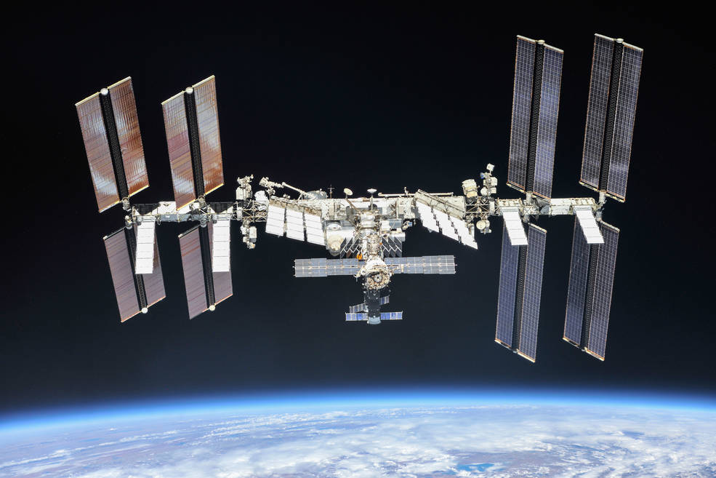

Image source: <https://www.nasa.gov/sites/default/files/thumbnails/image/iss056e201248.jpg>

* 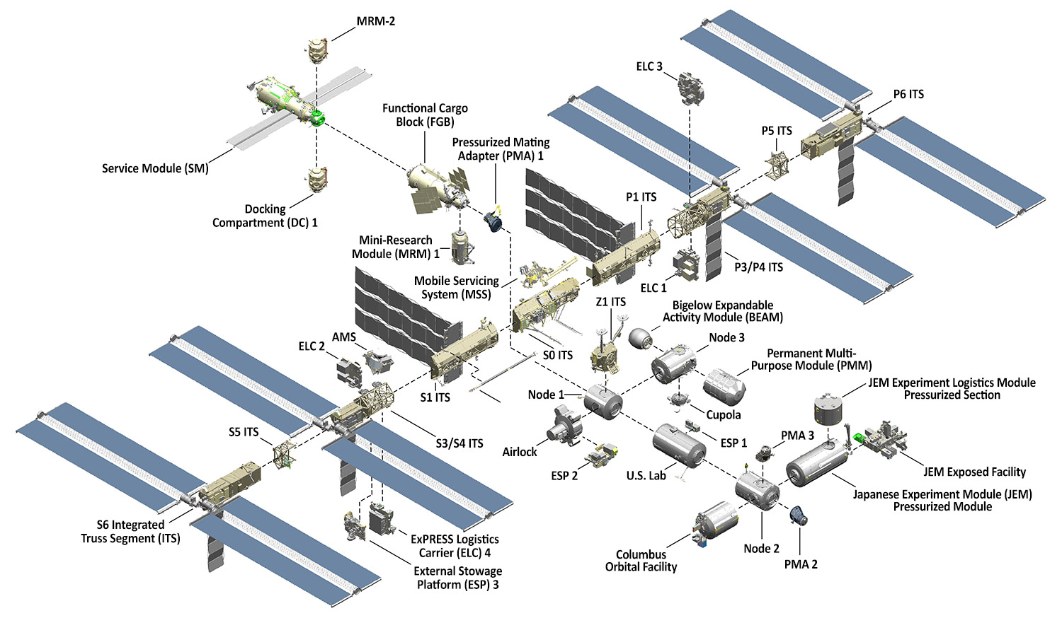Image, and parts of the International Space Station (ISS):

Image source: <https://www.nasa.gov/feature/facts-and-figures>

* Mission Overview of Canada Arm 2

**Technical Name:** International Space Station

**Launch Date:** November 20, 1998

**Mission:** Serves as home for astronauts, and for space research

**Ownership:** The United States, Russia, Canada, Japan, and specific countries of Europe

**Built by:** The United States (NASA), European countries (ESA), Japan (JAXA), Canada (CSA), and Russia (Roscosmos)

**Power Generation:** 8 solar arrays provide 75 to 90 kilowatts power

**Lines of Computer Code:** approximately 2.3 million

.

Source: <https://www.nasa.gov/feature/facts-and-figures>

**IMAGE GALLERY**

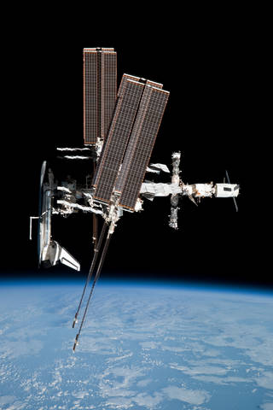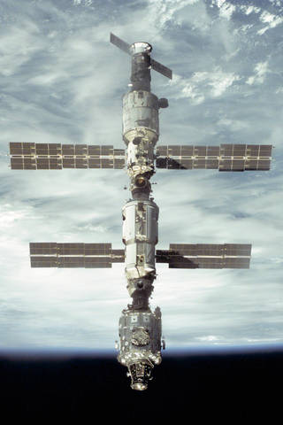

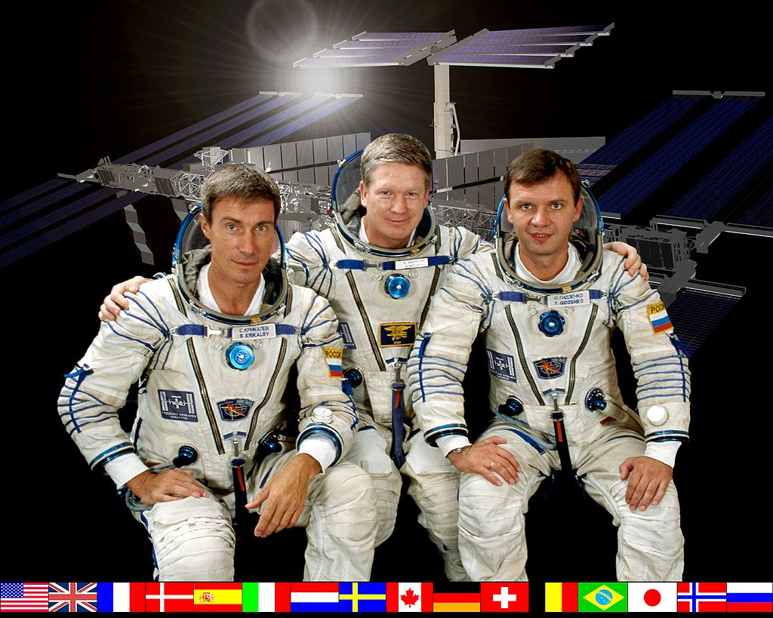

Image Source: <https://www.nasa.gov/multimedia/imagegallery/index.html>

**REFERENCES**

* <https://www.nasa.gov/>
* <https://www.nasa.gov/sites/default/files/atoms/files/np-2015-05-022-jsc-iss-guide-2015-update-111015-508c.pdf>
* <https://www.nasa.gov/audience/forstudents/5-8/features/nasa-knows/what-is-the-iss-58.html>
* <https://www.nasa.gov/audience/forstudents/5-8/features/nasa-knows/index.html>
* <https://www.esa.int/Our_Activities/Human_and_Robotic_Exploration/International_Space_Station/Building_the_International_Space_Station3>